Name: Furqan Ahmad
Registration No: 8297
Department: BS-CS
Subject: Mobile App Development
Assignment No: 03
Submitted To: Ma’am Sadaf Tanvir

Assignment:
Created accounts at all platforms that Ma’am told us about. Also created payoneer account and linked it as payout method. Following are the screenshots of the accounts I created:
- Truelancer:
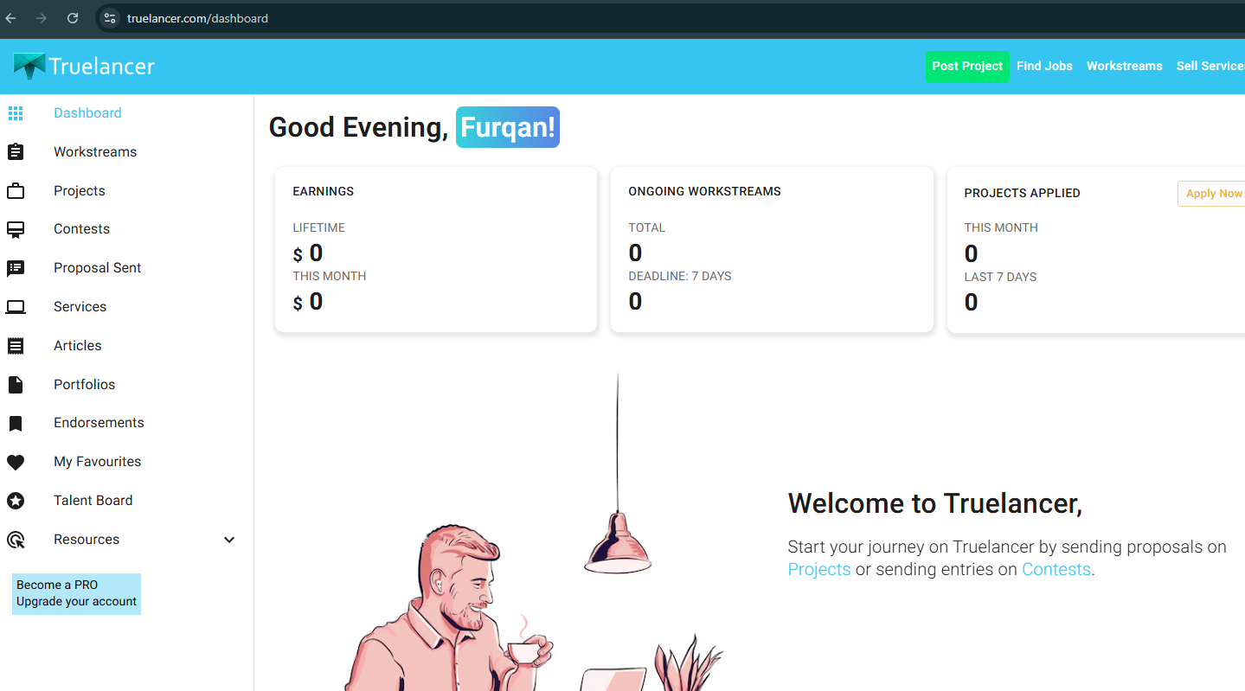

- Fiverr:
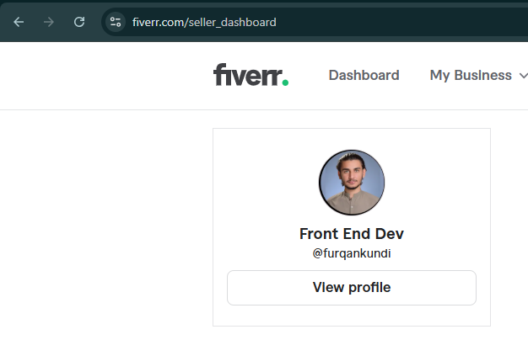

- Envato:
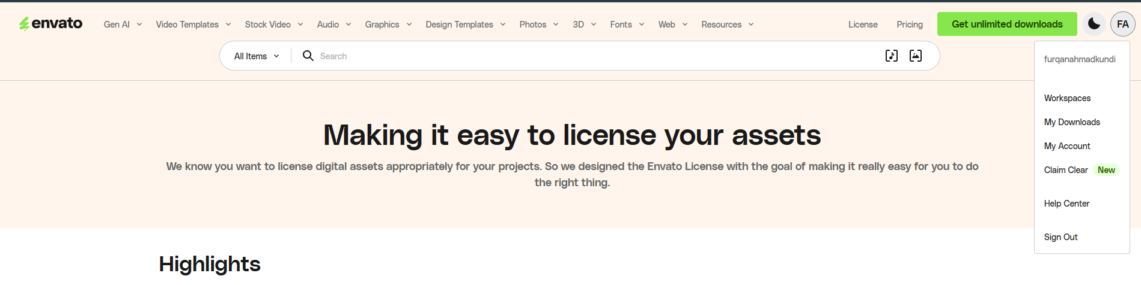

- ThemeForest:
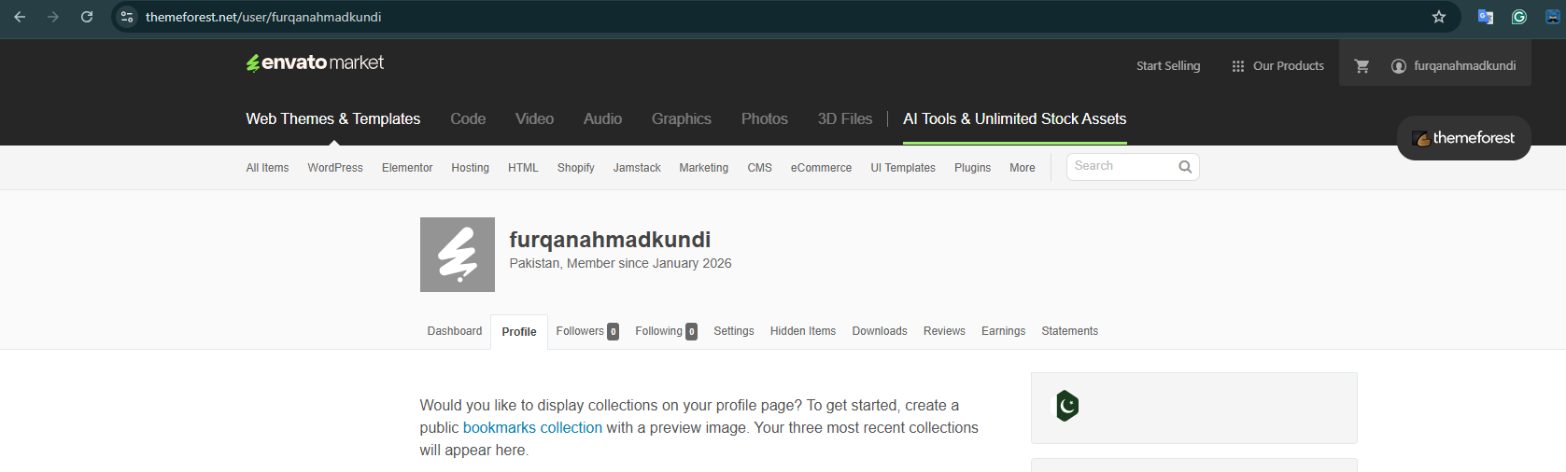

- CodeCanyon:
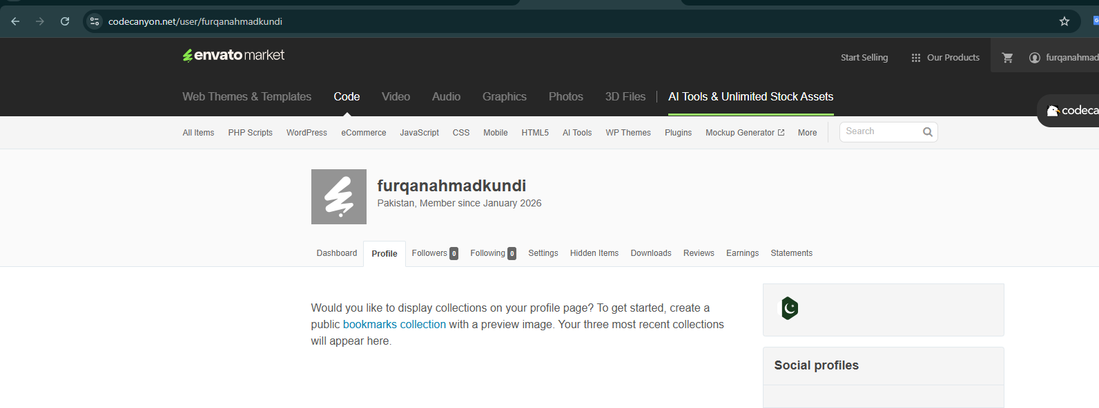

- Payoneer:
